**Kathford International College of Engineering and Management**

**Balkumari, Lalitpur, Nepal**



**Project Report**

**on**

**Home Service Maintenance**

**Submitted To:**

Department of Information Technology

Kathford International College of Engineering and Management

**Submitted By:**

Pragati Dahal, 25887

**Batch:** 2077

**Semester:** **V** Sem

**Year:** 2080

**September 2023**

# ABSTRACT

The Home Service Maintenance is your go-to website for all things home maintenance. Designed with simplicity in mind, it’s easy for homeowners to find the services they need. Built using HTML and CSS, the website connects you with skilled professionals for various tasks. The structured layout with HTML and the stylish touch of CSS ensure the website looks good and works well. Bringing together practicality and beauty, home service maintenance is here to make home maintenance a breeze for everyone. The website mainly focuses on the features of HTML and CSS only.

***Keywords: home service maintenance, go-to website, simplicity, HTML, CSS, skilled professionals***

# ACKNOWLEDGEMENT

I would like to acknowledge all of the professors who have been the source of my inspiration and encouraged me to prepare this report. I would like to thank Kathford International College of Engineering and Management for providing support and the proper environment for the project. I am grateful for their constructive suggestions and cooperation.

This report preparation has advanced my knowledge about HTML and CSS. I was able to complete this report due to the help and motivation of my friends, and teachers.

I am grateful to my lecturer, Ms. Sarita Neupane, whose contribution in stimulating suggestions and encouragement helped me coordinate my project. Finally, I am personally obliged and I express my sincere gratitude to all my teachers, and friends for their valuable instructions and constant support.

TABLE OF CONTENTS

ABSTRACT i

ACKNOWLEDGEMENT ii

INTRODUCTION 1

HOME PAGE 2

SERVICES 4

ABOUT US 8

CONTACT 9

FEEDBACK 10

IMPORTANT CODES 13

HEADER 14

FOOTER 15

IMAGE MAP 15

FORM 16

Media Query 17

LEARNING OUTCOMES 18

CONCLUSION 18

# INTRODUCTION

The Home service maintenance is a responsive website consisting of five main web pages. Each page is like a different webpage where you can learn about taking care of your home. Each webpage consists of three main parts: header, footer, and main section. The header and footer are the same for all the web pages but the main section is different depending on the webpage you are on where you can find different things to checkout. In this website, we have used all three types of CSS i.e. Inline, Internal, and External.

The five web pages of this website are:

* Home: The first webpage where you can get an overview.
* Services: The webpage that tells you about the services which will be provided.
* About Us: The webpage to know more about the service provider.
* Contact: The place to reach out if you need any help with your home.
* Feedback: The webpage for sharing your thoughts with the service provider.

# HOME PAGE

It is the first page of the website. It includes a well-organized navigation menu that makes it easy for users to access different sections of the website like "Services," "About Us," "Contact," and "Feedback." Also, include a footer at the bottom of the page.

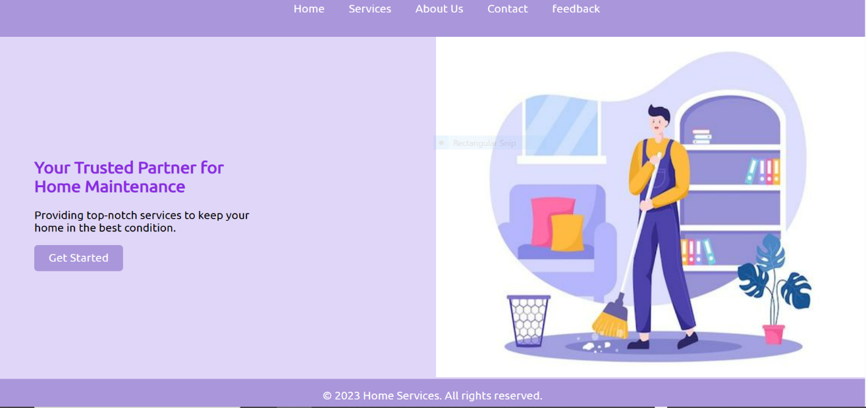

Figure 1 Homepage

**Navigation Bar:**

<header>

<nav>

<ul>

<li><a href="#home">Home</a></li>

<li><a href="services.html">Services</a></li>

<li><a href="about.html">About Us</a></li>

<li><a href="contact.html">Contact</a></li>

<li><a href="feedback.html">feedback</a></li>

</ul>

</nav>

</header>

header {

background-color: #aa96da;

color: #fff;

padding: 1em 0;

text-align: center;

}

nav ul {

list-style: none;

}

nav ul li {

display: inline;

margin: 0 15px;

}

nav ul li a {

text-decoration: none;

color: #fff;

}

**Footer:**

footer {

background-color: #aa96da;

color: #fff;

text-align: center;

padding: 1em 0;

}

**Hover:**

.cta-button {

display: inline-block;

background-color: #aa96da;

color: #fff;

padding: 10px 20px;

text-decoration: none;

border-radius: 5px;

transition: background-color 0.3s ease;

margin-top: 1rem;

}

.cta-button:hover {

background-color: #3c2e5e;

}

# SERVICES

The Services pageuses of image map. Image map has the clickable image having a clickable area which is used to navigate the link to other webpages. The use of a header and footer is also present when clicking on the navigation bar (header), which takes you to the respected webpage.

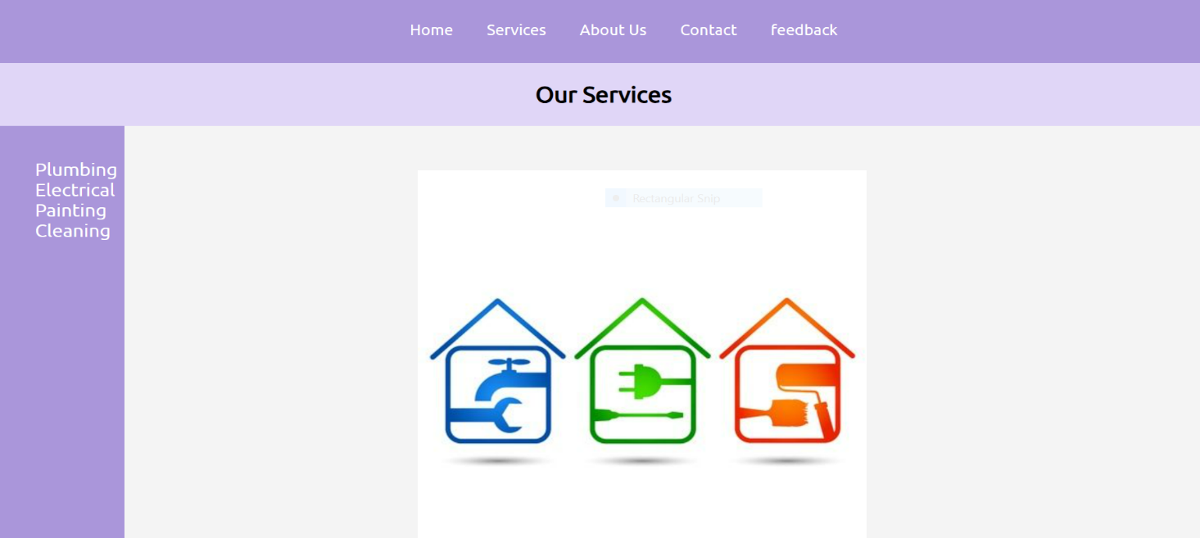

Figure 2 Services

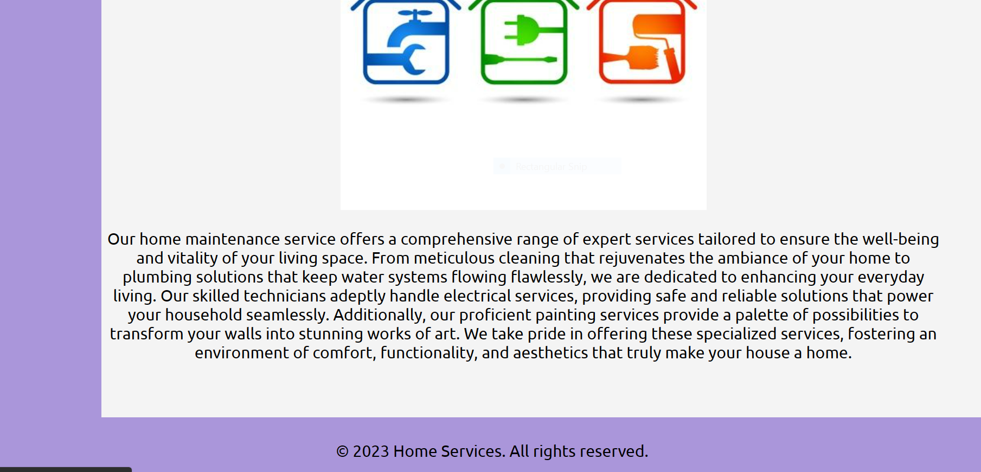

Figure 3 Service

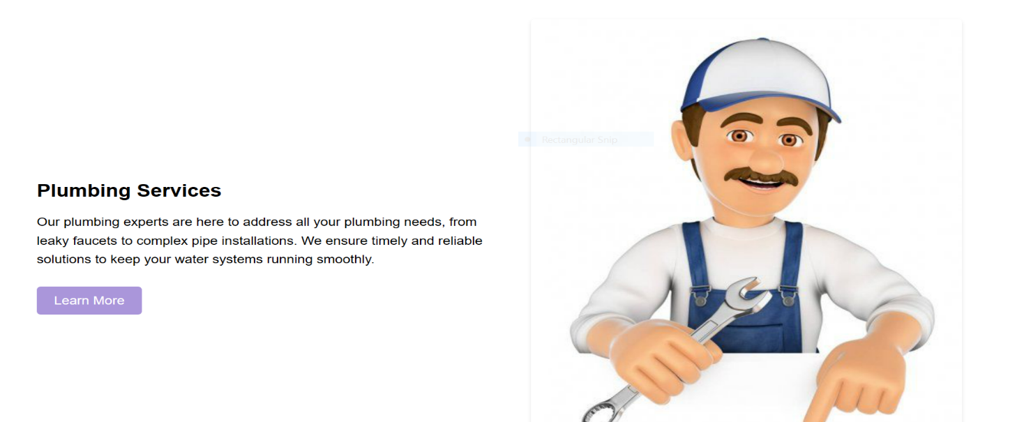

Figure 4 Plumbing Service

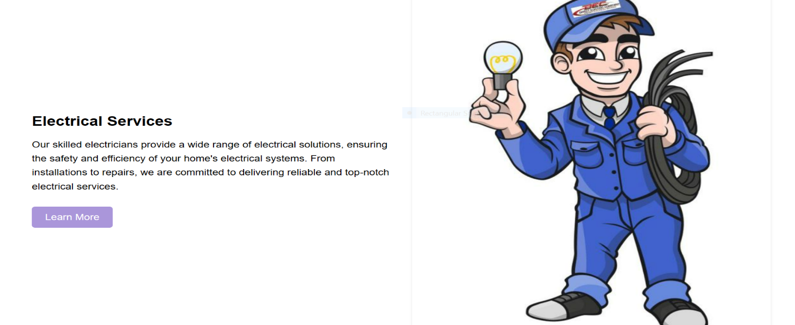

Figure 5 Electrical Service

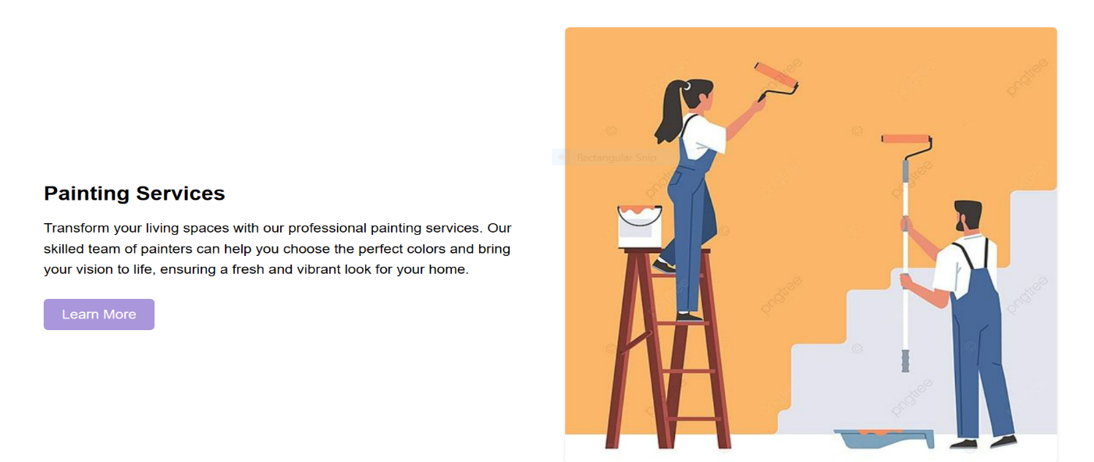

Figure 6 Painting Service

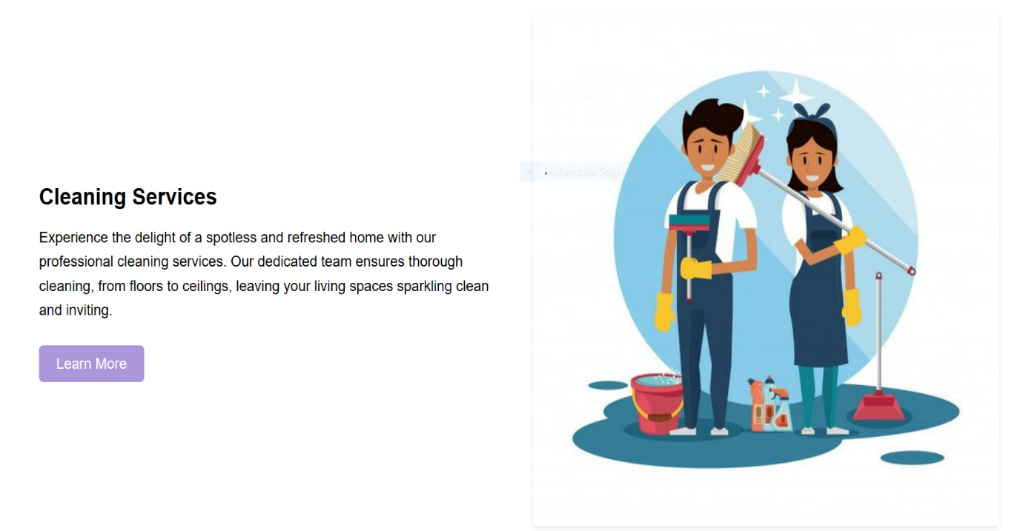

Figure 7 Cleaning Service

**Image map:**

<img

src="service_pic.jpg"

alt="Services Image"

usemap="#services-map"

/>

<map name="services-map">

<area

shape="rect"

coords="32,202,126,292"

href="plumber.html"

alt="Plumbing Service"

/>

<area

shape="rect"

coords="179,199,273,287"

href="elecrical.html"

alt="Electrical Service"

/>

<area

shape="rect"

coords="327,198,425,292"

href="painting.html"

alt="Painting Service"

/>

<area

shape="rect"

coords="23,423,430,18"

href="cleaning.html"

alt="Cleaning Service"

/>

</map>

# ABOUT US

About Us web page includes a description of the Home Service Maintenance website. Here, the details of the website and what type of service provided are explained. The use of a header and footer is also present in this webpage.

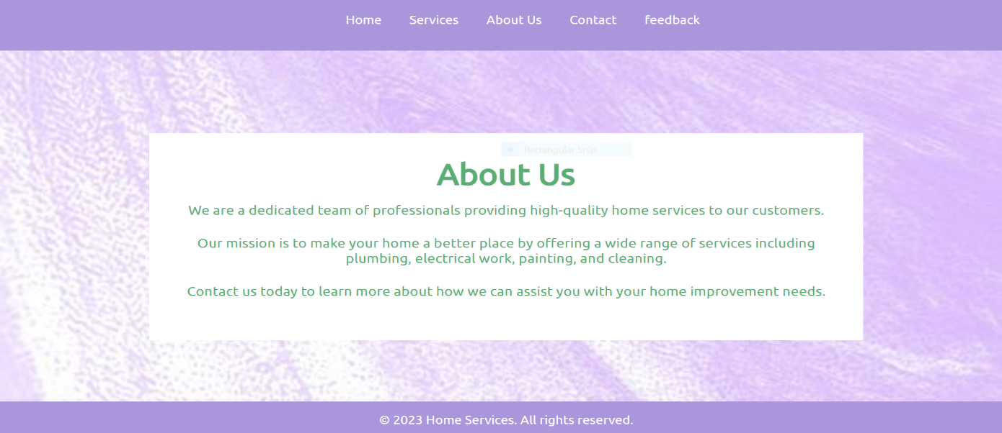

Figure 8 About us

**Background image:**

.about-us {

background-image: URL("about-uss.jpg");

background-size cover;

text-align: center;

padding: 7rem 0;

}

.about-us h1 {

font-size: 2.5rem;

margin-bottom: 1rem;

color: #5cad75;

}

.about-us p {

font-size: 1.5rem;

margin-bottom: 1.5rem;

font-weight: 200;

text-align: center;

color: #5cad75;

}

# CONTACT

This webpage includes the detailed contact for Home Service Maintenance. The use of a header and footer is also present in this webpage.

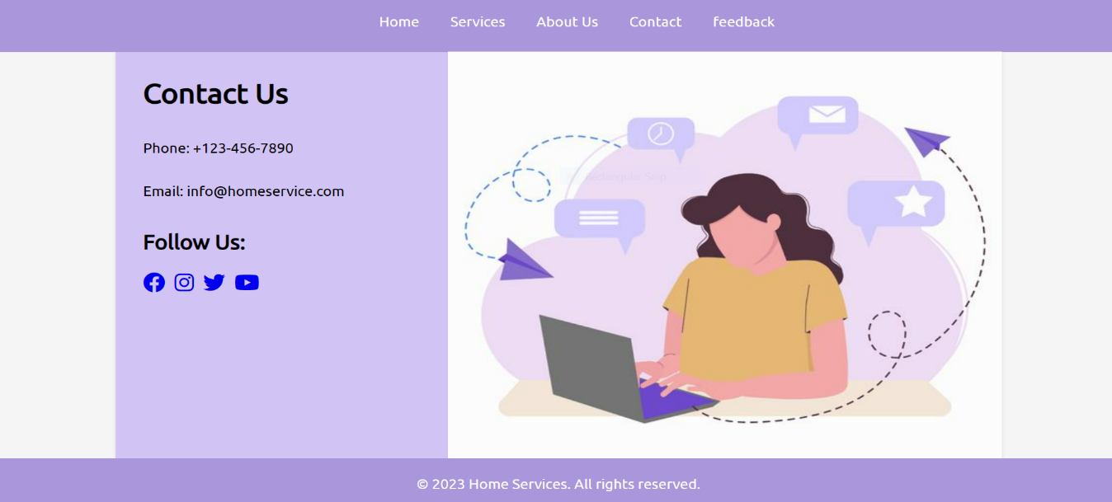

Figure 9 About Us

**Image:**

<div class="img">

<img src="contact.jpg" align="right" width="600" height="500" />

</div>

.img {

position: absolute;

top: 70px;

margin-left: 330px;

}

# FEEDBACK

In this webpage, we have used the form to get feedback from the customer. The use of a header and footer is also present in this webpage.

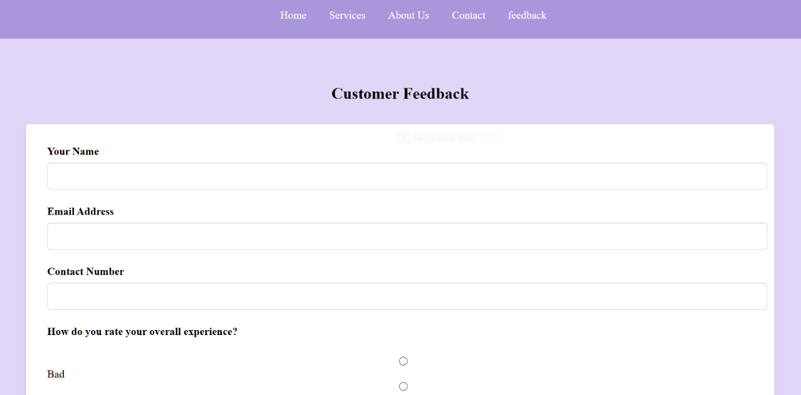

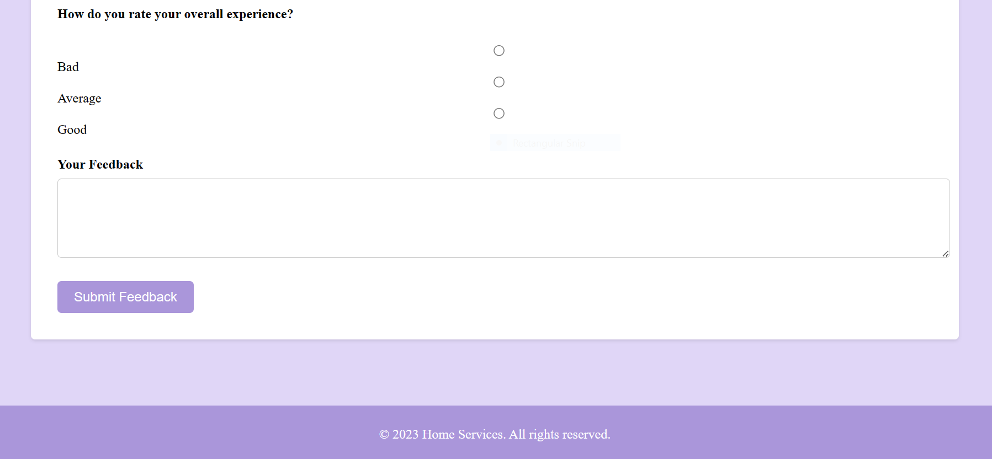

Figure 10 Feedback

**Form:**

<section class="feedback">

<h2>Customer Feedback</h2>

<div class="feedback-form">

<form id="feedback-form">

<div class="form-group">

<label for="name">Your Name</label>

<input type="text" id="name" name="name" required />

</div>

<div class="form-group">

<label for="email">Email Address</label>

<input type="email" id="email" name="email" required />

</div>

<div class="form-group">

<label for="contact">Contact Number</label>

<input type="tel" id="contact" name="contact" required />

</div>

<div class="form-group">

<label> How do you rate your overall experience? </label>

<br />

<input type="radio" name="rate" value="bad" />Bad

<input type="radio" name="rate" value="average" />Average

<input type="radio" name="rate" value="good" />Good

</div>

<div class="form-group">

<label for="feedback">Your Feedback</label>

<textarea

id="feedback"

name="feedback"

rows="4"

required

></textarea>

</div>

<button type="submit">Submit Feedback</button>

</form>

</div>

</section>

.form-group {

margin-bottom: 1.5rem;

}

.form-group label {

display: block;

font-size: 16px;

font-weight: bold;

margin-bottom: 0.5rem;

}

.form-group input,

.form-group textarea {

width: 100%;

padding: 10px;

border: 1px solid #ccc;

border-radius: 5px;

font-size: 16px;

}

# IMPORTANT CODES

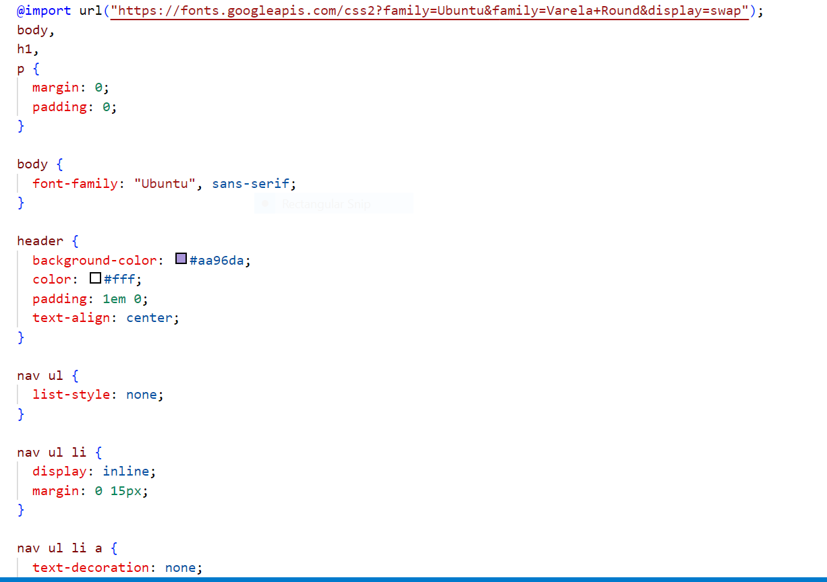

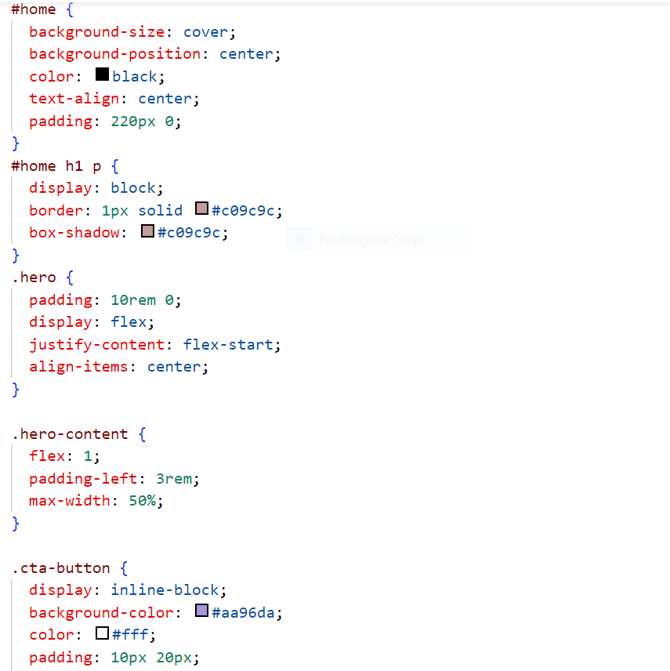

## HEADER

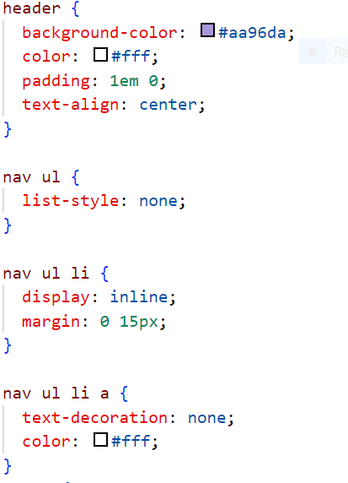

## FOOTER

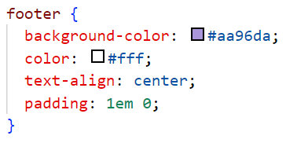

## IMAGE MAP

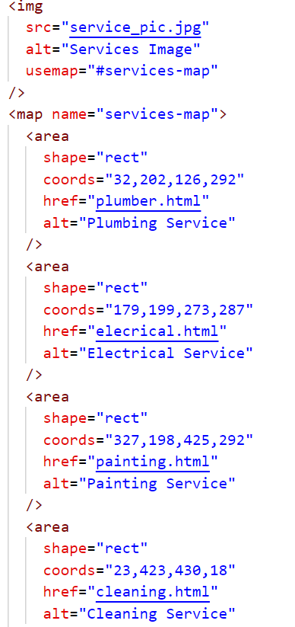

## FORM

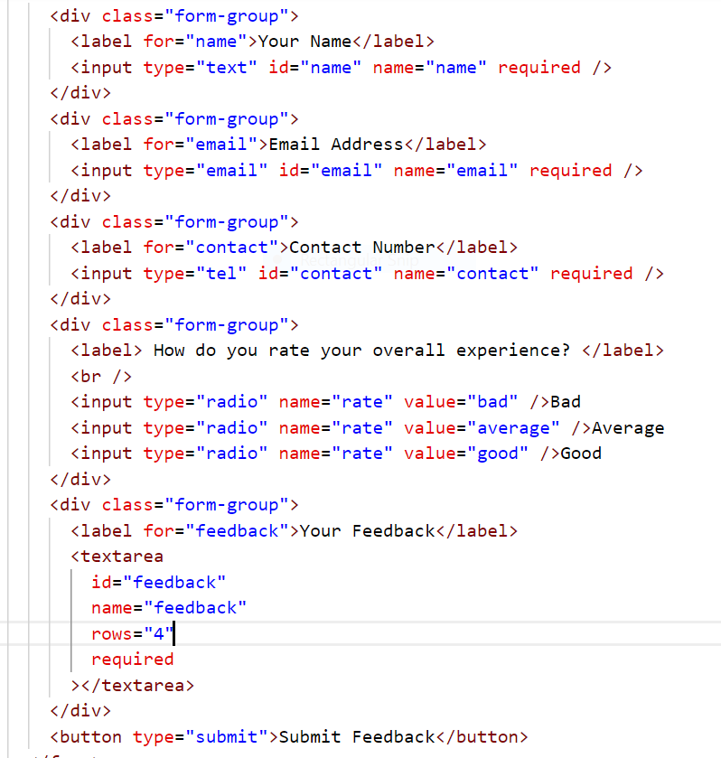

## Media Query

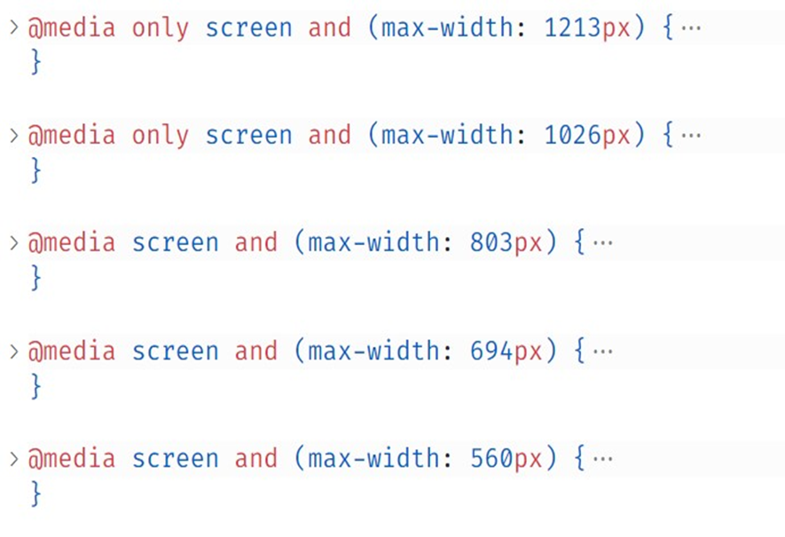

# LEARNING OUTCOMES

The learning outcomes from this project are:

1. Helped to improve our web development skills.
2. Designed a visually appealing and functional website.
3. Practical implementation of user-friendly website.
4. Increased online visibility for the project.
5. Improved user experience using navigation bar.

# CONCLUSION

In conclusion, embarking on a home service maintenance project using HTML and CSS provides a valuable opportunity to enhance web development skills and create an effective online presence for the service. Through the implementation of HTML and CSS, one can achieve a visually appealing and user-friendly website, improving the overall user experience.